**Travel Plan APIs Service**

In this project I am developing APIs for travel plan service. This service provides us various functionality about travel plans like existing plans and categories. And also having options for modify plans and categories, also we can check specific plan, category and other few functionalities like delete, view by active status etc.

For UI, I am working on some pages to view this service.

For developing this APIs Service I use following tech. and tools:

1. Spring Boot technology for developing APIs
2. For Database I use MySQL
3. For test APIs using Postman as well as swagger tool.
4. For UI I will use ReactJs.

**To achieve this functionality,**

1. Create schemas using MySQL Database and connect with backend technology i.e. Spring Boot
2. And for creating various APIs I use STS tool for Spring Boot project.
3. Project structure are:

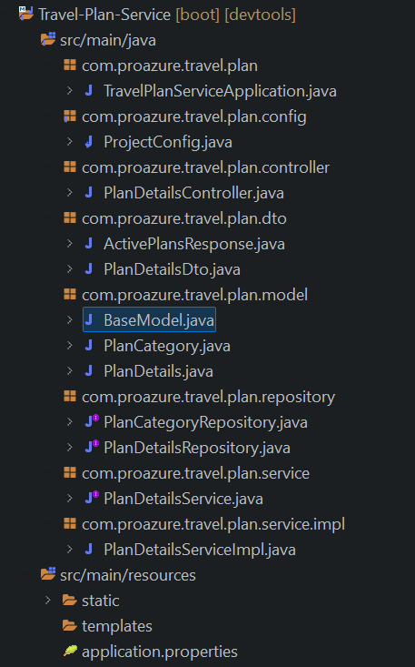

1. Set database connection with Spring Boot in application.properties like:

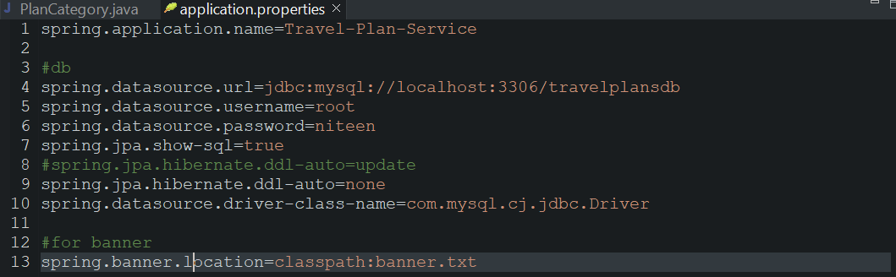

1. In this service developed following APIs and their Requestbody and Responsebody are :
2. **API for save plan:**

API method : Post

API path : ‘/api/v1/plan/save’

Requestbody : {

    "planName" : "Demo plan",

    "planDescription" : "This demo plan description",

    "planBudget" : 59.00,

   "planCategory" : {

            "categoryId": 1

   },

    "createdBy" : 1

}

Responsebody: {

Travel Plan Save Successfully!

}

**Response from API on successful creation of plan details:**

**status code 201(Created)**

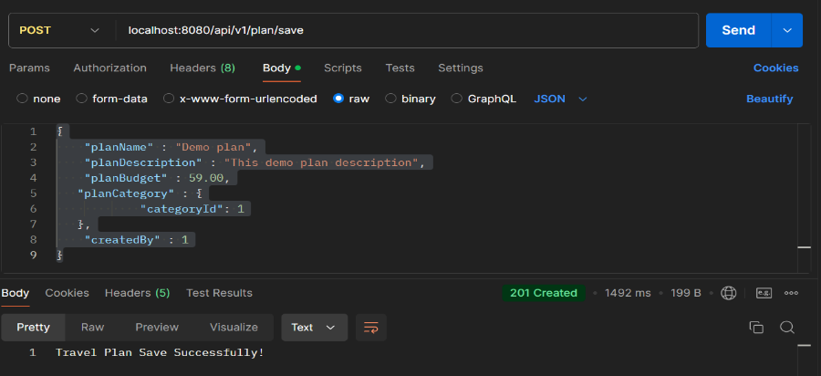

--------------------------------------------------------------------------------------------------------------------------

1. **API for get all plans :**

API method : Get

API path : ‘/api/v1/plan/’

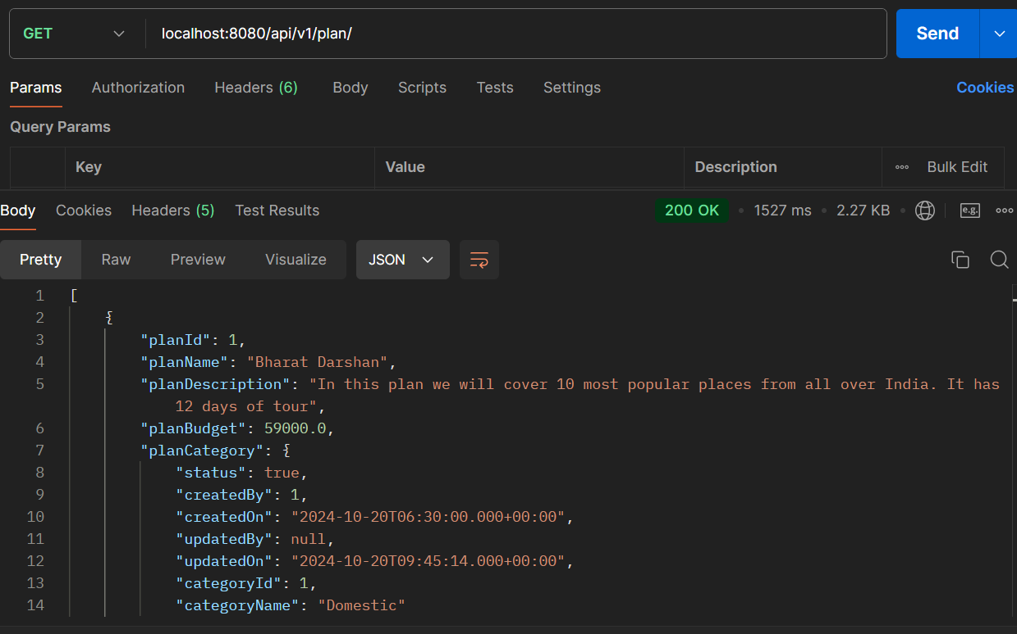

**Response from API on successful retrieve plans from db:**

**status code 200(Ok)**

**--------------------------------------------------------------------------------------------------------------------------------------**

1. **API for delete plan by id :**

API method : Delete

API path : ‘/api/v1/plan/{plan_id}’

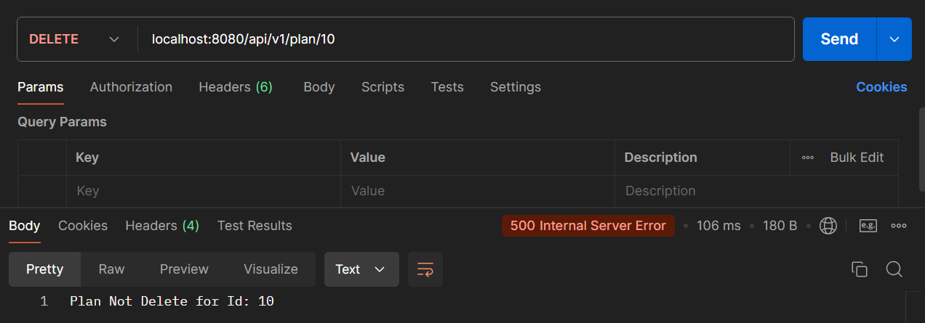

* This is response when plan is not present in database.

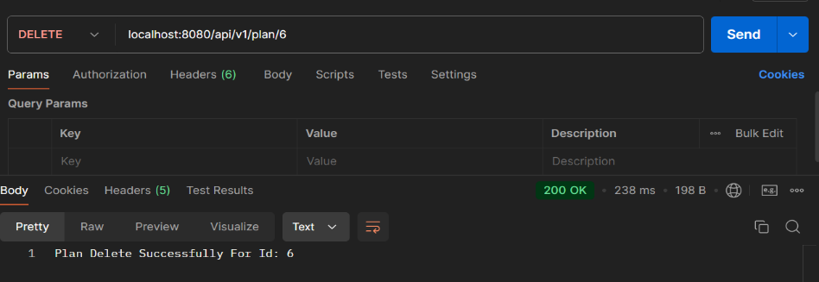

Here,

**Response from API on successful Delete plan from db:** **status code 200(Ok)**

**--------------------------------------------------------------------------------------------------------------------------------------**

1. **API for update plan :**

API method : Get

API path : ‘/api/v1/plan/save’

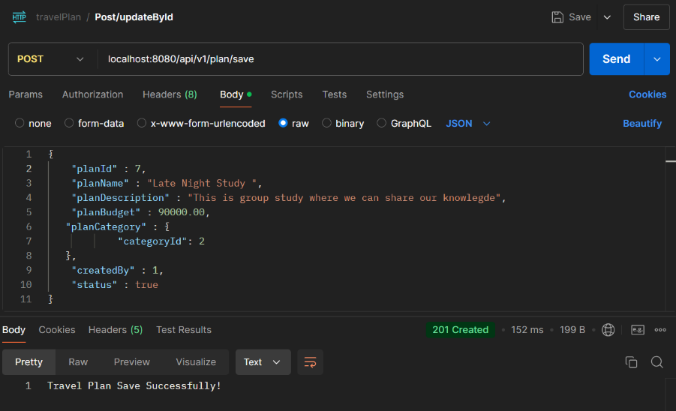

**Response from API on successful Update of plan details:**

**status code 201(Created)**

**--------------------------------------------------------------------------------------------------------------------------------------**

1. **API for get plan by id :**

API method : Get

API path : ‘/api/v1/plan/{plan_id}’

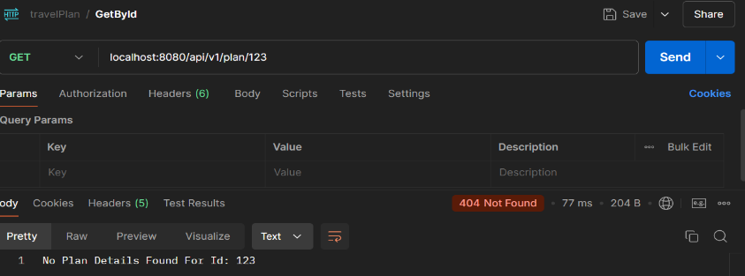

* This is response when plan is not present in database.

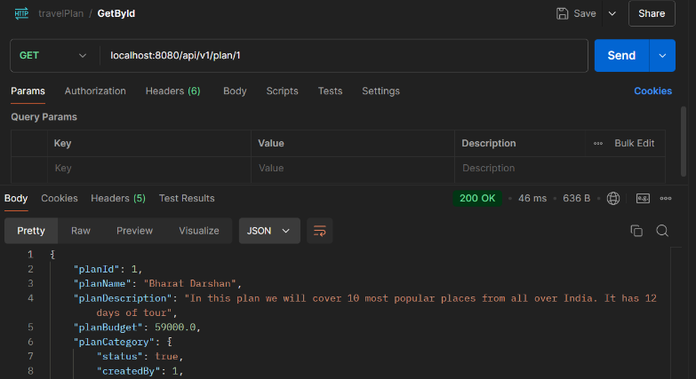

**Response from API on get plan details by id:**

**status code 200(Ok)**

--------------------------------------------------------------------------------------------------------------------------

1. **API for get plan by id whose status is active :**

API method : Get

API path : ‘/api/v1/plan/active’

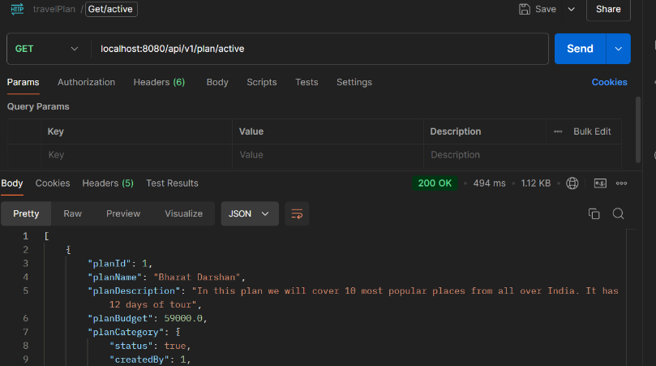

**Response from API on get plan details by id whose status is active :**

**status code 200(Ok)**

--------------------------------------------------------------------------------------------------------------------------